***dt : 1/10/2022***

***=>In realtime these inheritances are categorized into two types:***

***(a)Single Inheritance***

***(b)Multiple Inheritance***

***(a)Single Inheritance:***

***=>The process of extracting the features from one class at-a-time***

***is known as Single Inheritance.***

***Ex:***

***above program***

***(b)Multiple Inheritance:***

***=>The process of extracting the features from more than one***

***class at-a-time is known as Multiple Inheritance process.***

***Diagram:***

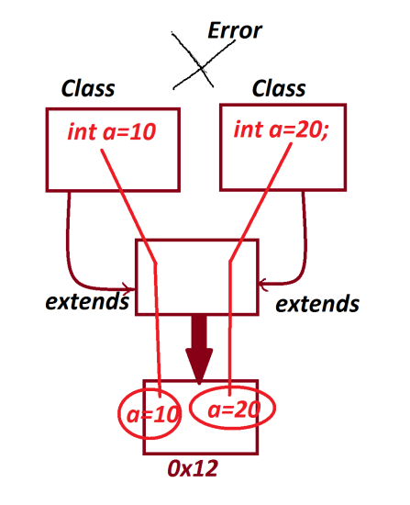

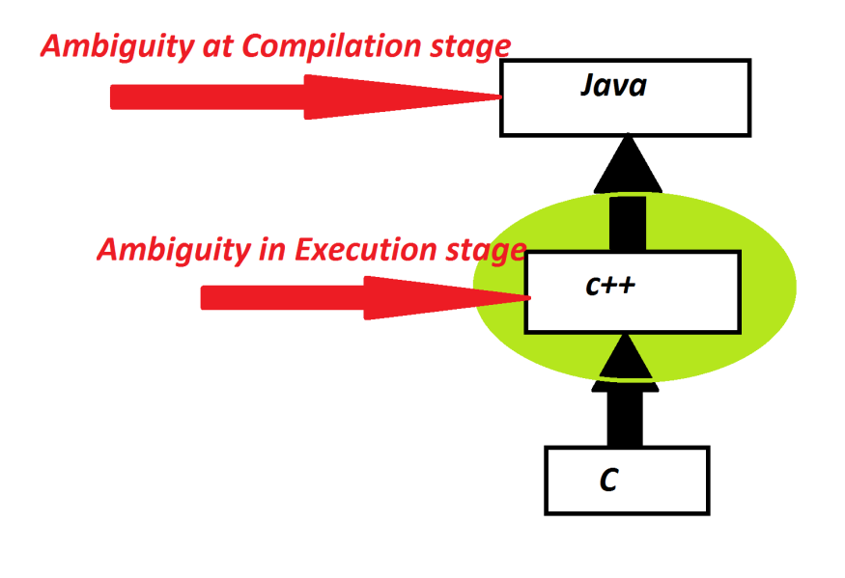

***Note:***

***=>Multiple Inheritance process using Classes not available in Java,***

***because which leads to replication of programming components and***

***raises ambiguity,the ambiguity state applications will generate***

***wrong results.***

***=>In Java,using Interfaces we can perform Multiple inheritance***

***process.***

***===========================================================***